**ActiveNet Private Lesson Quick Reference Guide**

* **Creating Private Lesson Activities**
* **Establishing Best Practices**

**Table of Contents**

ActiveNet Private Lesson Activity Quick Reference Guide 3

Preliminary Data Gathering 3

General Information 4

Location Information 5

Occurrence Information 6

Type (Who) Information 8

Number of Students 9

Text Fields 10

Activity Options 11

Private Lesson Options 13

Open/Close Times 15

Instructor Assignment 16

Pre-Requisites 19

Fees 21

Payment Plans 30

Custom Questions 34

Interest Lists 35

Checklist Items 36

Sub-Activities 37

Conclusion 38

**Private Lesson Quick Reference Guide**

The purpose of this document is to describe and illustrate through brief explanation and screen shots the process for creating private lesson activities in ActiveNet.

**The following programs *must* be created prior to creating Private Lessons:**

* Activity Types >Located: Administration>Registration Settings
* Sites>Located: Administration>Locations
* GL Accounts>Located: Administration>Financial Settings
* Charges>Located: Financial Settings
* Seasons/Terms>Located: Administration>Registration Settings

**The following *should* be created prior to creating Private Lessons:**

* Centers>Located: Administration>Locations
* Facilities>Located: Administration>Facility Settings
* Department>Located: Administration>System Settings
* Activity Category>Located: Administration>Registration Settings
* Activity Sub Category>Located: Administration>Registration Settings
* Instructors>Located: Administration>Registration Settings
* Skills>Located: Administration>System Settings
* Supervisors>Located: Administration>Registration Settings

**The following Field descriptions defined:**

* Required: System requires field
* Recommended: Not required, but recommended
* Optional: Not required, typically not used

**The following fields apply for building private lessons**

**General Information**

***Field:* Name (required)**

Enter the name of the Activity.

* Develop a standardized naming convention which will facilitate long-term use and ease of reference.
* The Name prints on the receipt

***Field:* Type (required)**

* Activity Type defines if the course component allows Private Lessons

***Field:* Activity Number (required)**

* Activity Number may be auto-assigned via Registration Settings>Configuration

***Field:* Status (required)**

* When creating activities, assigning Open or Tentative are typically assigned

***Field:* Department (recommended)**

* Department defines the primary division or branch of the organization

***Field:* Activity Category (recommended)**

* The primary grouping method for like Activities
  + Example: Private Instruction, Group Composition, Early Childhood

***Field:* Activity Other Category (recommended)**

* The sub grouping, or granulated method for like Activity Categories
  + Example: Cello, Suzuki Violin, Violin

***Field:* Catalog Description**

* Shows on Public Access and prints on Activity Catalog

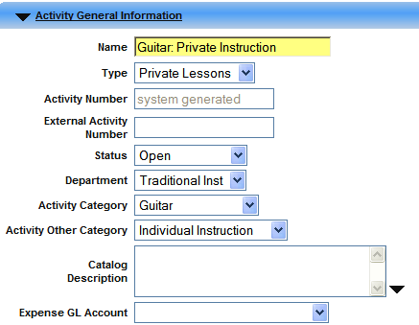

**Location:**

***Field:* Site**

* Select the Site applicable for the Activity
  + A Site is the administrative controlling body that controls the financial information for all components of ActiveNet. A site should be maintained for each location that operates as its own business unit.

***Field:* Add Facility (optional)**

* Click **Add Facility** to search and select the applicable Facility(s)
* Click “Don’t reserve Facilities” if the Facilities *should not* be scheduled.
  + The system assumes the Activity will book the assigned Facililty(s)

***Field:* Location Description**

* Entering a Location Description will override the assigned Facility(s) on Public Access.
  + Example: if unsure where an Activity will be held, use the Location Description to define the meeting location

***Field:* Preparation Code:**

* Optional: Use for assigning preparation setup and cleanup times as well as room preparation text.

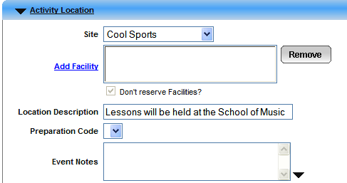

**When (occurrence):**

***Field:* First Date/Last Date (required)**

* Enter First and Last Meeting Date for Activity
  + Check the “Don’t Create Meeting Dates” for Private Lesson Activities

***Field:* Date Description (optional)**

* Overrides the assigned First and Last date shown on Public Access. The “Enter Date Description” field must be checked to enable this text table.

***Field:* Semester (required)**

**Term (required)**

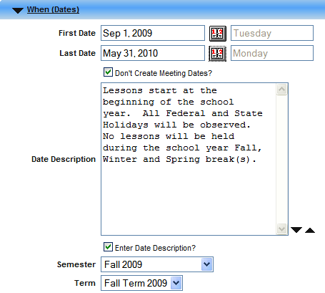

**When (occurrence):**

***Field:* When (Days) (required)**

* Select days of week activity meets

**Week of Month (required)**

* Recommend leaving all checked

***Field:* When (Times) (required)**

* Enter Beginning Time
  + Earliest Time Private Lesson may be scheduled

***Field:* Duration (required)**

* Enter the entire number of hours Private Lessons may be scheduled for a single day
  + DO NOT enter the duration of the lesson! The lesson duration is specified elsewhere.

***Field:* Setup and Cleanup Time (optional)**

* Enter setup and cleanup time for Activity

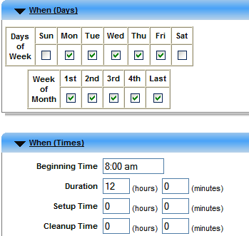

**Type of Student (who):**

***Field:* Residency Type (optional)**

***Field:* Gender (required)**

***Field:* Minimum Age (recommended)**

***Field:* Maximum Age (recommended)**

* Advance the maximum age 1 year when assigning. For example, if the maximum age is 18, enter 19. Public Access will display “At least 5, but less then 19.”

***Field:* Grades (optional)**

* It is not permissible to assign Age and Grade ranges. Use one or the other

***Field:* Age Calc Date (optional)**

* The system determines if the student’s age meets the minimum age requirements by calculating the date of birth and comparing with the First Meeting Date. If the student must be the minimum age before or after the First Meeting Date, specify the date here.
  + Example: U9 Youth Soccer requires players be a minimum of 9 years of age in August, although the sport begins in the Spring.
  + Example: Preschool programs beginning in March may require child is 3.5 years of age by January 1st.

***Field:* Maximum Age for Multi-person Fee (optional)**

* If the activity offers a sibling or multi-person discount, you must enter the maximum age for the discount in this field. Typically, the maximum age for the activity will be entered in this field.

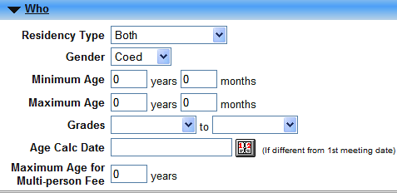

**Number of Students:**

***Field:* Minimum (optional)**

* Enter the minimum number of participants. This value will publish online, and there are several Registration reports, which identify activities which have not met the minimum.

***Field:* Maximum (optional)**

* Enter the maximum number of participants. If blank, the system assumes the activity is full. If checking the unlimited field, the system will publish the maximum capacity as Unlimited. The system will verify the maximum capacity does not exceed the maximum capacity for the facility(s).   
  **Note:** When using Sub Activities, you may want to leave this field blank for the Parent activity.

***Field:* Maximum Enrollment Per Receipt (optional)**

* Maximum Enrollment Per Receipt
  + Entering a value in this field will establish a cap for the maximum number of participants that may enroll for one receipt.

***Field:* Trial Class Capacity (optional)**

* This field will allow participants to register for a class on a trial basis. If a program offers 6 classes, entering a value of 1 would allow the participant to pay a unique fee, then ideally enroll into the activity for the remaining classes.

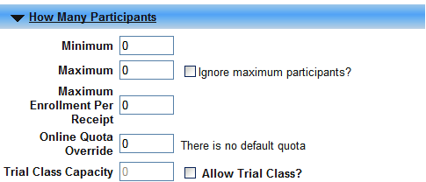

**Text:**

***Field:* User Notes (optional)**

* User Notes trigger the “Red Alarm Alert” when enrolling the participant. Once the activity is selected, the system will display the alert, allowing the staff person to click and view notes. This table is ideal for internal notes concerning the activity which the staff should review prior to completing the enrollment.

***Field:* Online Notes (recommended)**

* Online Notes will appear in bold red on Public Access. Online Notes do not providing formatting opportunities as the Catalog Description. **Example: Entering the following text:**

**All participants must bring the following each day of camp:**

* + - 1. **Towel**
      2. **Sack lunch**
      3. **Swimsuit**
      4. **Athletic shoes**

**Will appear as:**

**All participants must bring the following each day of camp: 1. Towel 2. Sack lunch 3. Swimsuit 4. Athletic shoes.**

*\*Best practice suggests using brevity when entering notes for this field* .

***Field:* Receipt Notes (recommended)**

* Receipt Notes print directly under the enrollment information on the receipt. Typically, the Online Notes would be duplicated in the Receipt Notes. See below for an example.

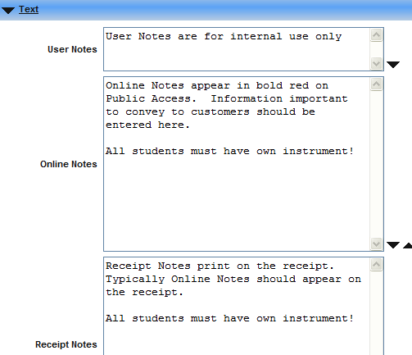

**Activity Specific Options:**

***Field:* No Internet Registration (optional)**

* Check when you wish to show the activity, but not allow online registration.

***Field:* Hide on Internet? (optional)**

* Check if the activity should be hidden to the public.

***Field:* Notification On (optional)**

* Notify staff via email when participant enrolls online.

***Field:* No Quantity Based Enrollment (recommended)**

* The majority of activities will be No Quantity Based. An example of a “Quantity Based Enrollment” would be an Easter Egg Hunt, or Daddy Daughter Dance. You have a registrant purchasing 3 seats, but you are not concerned with a name for each seat. No Quantity Based enrollments would require a participant for each seat purchased. This default is established in the Registration Settings>Configuration program.

***Field:* Use Pass or Fail? (optional)**

* Checking this field will configure the activity as pass or fail. Swim lessons, Martial Arts, etc. are popular Pass/Fail programs.

***Field:* Allow Internet Marking? (optional)**

* When the Use Pass or Fail field is checked, the option to check this field is enabled. When checked, this field will allow the assigned Instructor to update participants pass/fail status through public access. Remember, the Instructor record must be flagged to “Allow online Administration” field is checked.

***Field:* Require Withdraw Reason? (recommended)**

* Require withdraw reason when withdrawing student from activity.

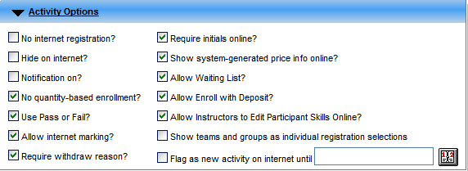

**Activity Specific Options:**

***Field:* Require Initials Online? (optional)**

* If checked, public access will require customer to enter initials prior to advancing to payment screen. Recommended checking.

***Field:* Show System Generated Price Info Online? (recommended)**

* Show pricing information to public online.

***Field:* Allow Wait Listing? (optional)**

* Check if course specifies a maximum enrollment.

***Field:* Allow Enroll with Deposit? (optional)**

* If the activity permits a place, hold for the student by remitting a monetary or zero amount deposit, check box.

***Field:* Allow Instructors to Edit Participant Skills Online? (recommended)**

* If Skills will be assigned to Customer record, this field will permit the assigned Instructor to update student’s skill.

***Field:* Flag as new activity on internet until: (optional)**

* Use only if activity is new to the organization and public.



**Private Lesson Options:**

***Field:* Allow Private Lessons Bookings (required)**

* Identify if the activity permits Private Lesson bookings

***Field:* Allow Private Lessons Bookings Online (optional)**

* Permission to allow public access private lesson requests

***Field:* Maximum Lessons Per Enrollee (required)**

* Maximum number of private lessons per student

***Field:* Minimum Lessons Per Enrollee (required)**

* Minimum number of private lessons per student

***Field:* Allow Selecting Desired Booking Quantity Per Enrollee (optional)**

* Permit selecting unique number of private lessons during enrollment.

***Field:* Allow Selecting Desired Booking Quantity Per Enrollee Online (optional)**

* Permit selecting unique number of private lessons during enrollment online.

***Field:* Minimum Advance Hours for Online Booking Changes (optional)**

* Number of advance hours required for booking changes made online.

***Field:* Maximum Private Lessons Duration (required)**

* Maximum duration for private lesson in hours or minutes.

***Field:* Minimum Private Lessons Duration (required)**

* Minimum number of hours or minutes for private lesson.

***Field:* Booking Grid Interval (required)**

* Determine time grid interval when selecting private lesson time. Typically set to 15 minutes.

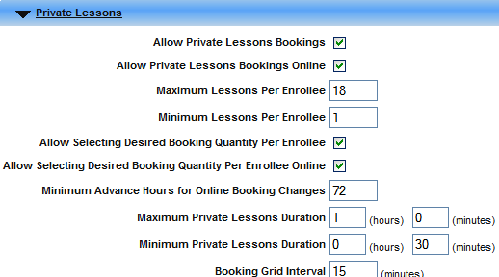

**Private Lesson Booking Pattern:**

***Field:* Enforce Booking Pattern (optional)**

* Will require booking pattern remain static

***Field:* Frequency (required if above field checked)**

* Specify the frequency or schedule of the booking. Options are:
  + Weekly
  + Bi-Weekly
  + Monthly

***Field:* Keep Same Day of the Week (optional)**

* If checked, system will require the Booking Pattern to maintain the same day of the week.

***Field:* Keep Same Start and End Times (optional)**

* If checked, system will require the Booking Pattern to maintain the same lesson start and end time.

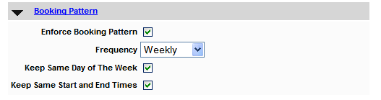

**Open/Close Registration Times:**

***Field:* First Day/Time In Person (recommended)**

* Enter the walk-in, mail-in first date of registration. If the First Day/Time on Internet field is blank, the First Day/Time In Person will be the Internet date default.
  + Consider opening public access ahead of First Day/Time in person.
    - Modify the hours for Internet to allow after midnight enrollments on first day.
    - Open online enrollment for Internet days ahead of walk-in or mail in to encourage public access.

*Assumptions are the same for remaining fields*

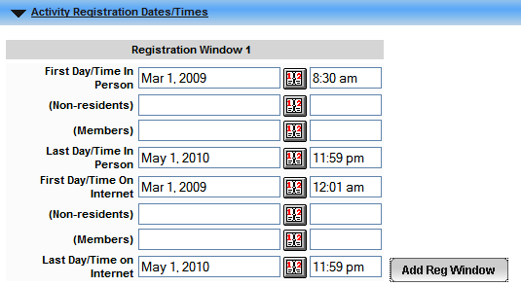

**Instructor and Personnel Assignment:**

***Field:* Instructor (recommended)**

* If the Instructor is known, select now. If multiple Instructors will be assigned, do not select now. The system will issue a message opting to assign all Instructors with same Activity Type.

***Field:* Supervisor (recommended)**

* Assign the personnel associated with the activity. This information will display online as contact personnel for the activity.

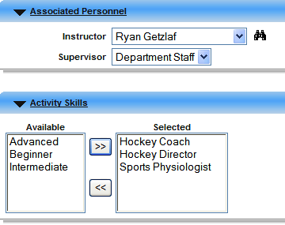

**This message will appear automatically after submitting the page.**

* Answer OK to assign all Instructors with the same Activity Type.
  + Example: Instructors with Activity Type = Private Lessons will be assigned to the activity when selecting “OK.”
* Selecting Cancel will omit automatic Instructor assignment.

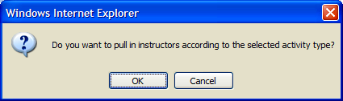

**Back to Activity Functions**

**This screen shows the numerous options available for constructing activities. Not all programs will be used for Private Lessons.**

**The following pages explain how to configure the most commonly used programs associated with Private Lessons.**

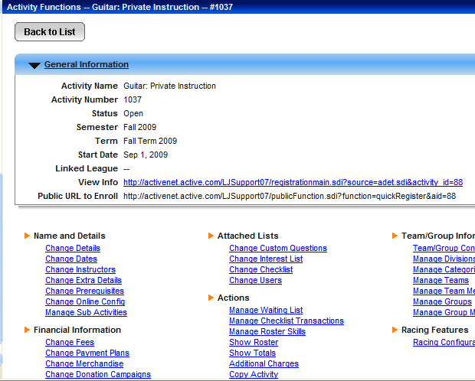

**Change Instructors**

This program allows selecting individual instructors.

This program provides the ability to link one or more instructors to an activity and define the rate at which the instructor is paid. The rates are reflected from the instructor record but may be changed accordingly when adding the instructor to the activity.

Click Add New to add Instructor(s).

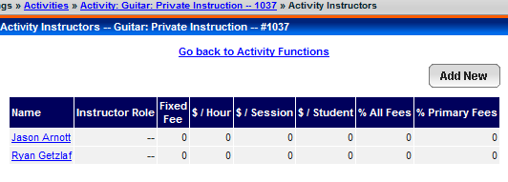

**Change/Add Prerequisites**

This program provides the ability to define pre-requisites for Private Lesson enrollment.

Example: If students must pay an annual Registration Fee prior to Private Lesson enrollment, creating a pre-requisite activity “Registration Fee” and adding the activity as a pre-requisite ensures all students pay the registration fee, and provides the site with a Roster.

To assign the pre-requisite, click the binoculars beside “Prerequisite Activity.”

Search and select applicable activity.

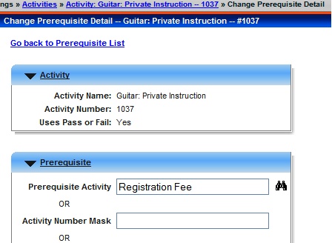

Assignment of a Time Limit is required. Typically, 1 year is acceptable since the Prerequisite activity already stores a beginning and ending date and will therefore correlate with the Private Lesson activity.

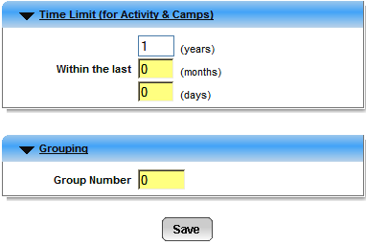

**Change/Add Prerequisites**

The system will allow multiple Prerequisite assignments. To add additional prerequisites, click Add New.

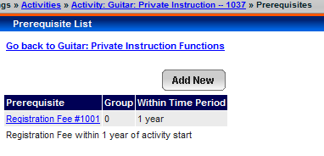

**Change/Add Fees**

A variety of fees may be associated with Private lessons including tuition, scholarships, discounts, and materials.

Fees, Discounts, and Scholarships must be created individually. In other words, you cannot embed a discount within a fee. Additionally, the general ledger account assigned to the Charge is specific to the charge. In other words, a general ledger detail record will be written to the general ledger chart of accounts when the system encounters the fee, discount, or scholarship. Therefore, accurate assignment of the GL account is paramount to the financial integrity of the system.

Each fee, discount, or scholarship will be reflected as a “charge” in the system. All charges must be created first in the Administration>Financial Settings>Charges program.

**Click Change Fees to Add fee**

**Click Add New to add Fee or Discount**

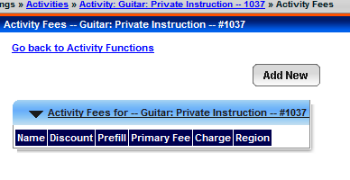

**Select from the drop down to select the applicable charge:**

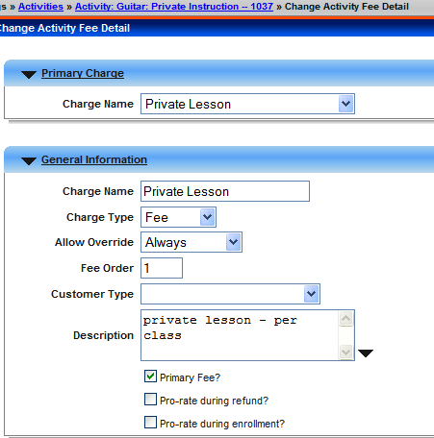

**Change/Add Fees, considerations:**

**General Information:**

***Field:* Charge Name (required)**

* Override the Charge Name from the Charge Name table previously selected. Or, modify the Charge Name using the **Description** field.

***Field:* Charge Type (required)**

The Charge Type default should be used, however it is permissible to override this.

* + Example: change the Charge Type from Fee to Discount

***Field:* Fee Order (recommended)**

The fee order determines the sequence which the fees will display online and offline.

* + Please note: for online transactions, customers will only see the discounts which they qualify for.

***Field:* Customer Type (optional)**

Customer Type is most commonly used for Staff or Employee discounts. Using the Customer Type to segregate Staff or Employees is efficient and reliable.

***Field:* Primary Fee (recommended)**

The Primary Fee field ***must*** be checked if the fee is the tuition or primary fee. The Primary Fee will display online and during search results. The Primary Fee is typically what Instructors are paid from.

***Field:* Pro-rate during refund? (optional)**

Check if this charge should be pro-rated when refunding

***Field:* Pro-rate during enrollment (optional)**

Check if this fee should be pro-rated during enrollment.

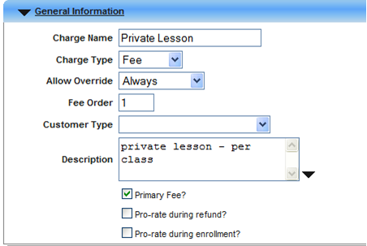

**Change/Add Fees considerations;**

**Fee Information:**

***Field:* GL Account (required)**

Use the default GL Account or use the drop down and select the applicable general ledger account.

***Field:* Charge Amount (recommended)**

Enter the Charge or Discount amount.

***Field:* Discountable (optional)**

Check if the Fee can be discounted. Do not check this fee if the *charge* is a discount.

***Field:* Exclude from Payment Plans? (optional)**

Check if the Fee should be excluded from payment plans. If checked, the system will require remitting payment before completing the transaction. This field may be used for organizations assigning a service fee for customers opting in for a payment plan. Or, for organizations assigning a registration fee to the Private Lesson activity.

***Field:* Trial Class Fee (optional)**

Check if the fee is applicable for Trial Class. If checked, the system will enable the fee when enrolling into a Trial Fee class.

***Field:* Per Booking Fee (recommended)**

Check for Private Lessons if tuition is charged per lesson.

***Field:* Per Booking Per Hour Fee (optional)**

Check if the fee will be calculated according to the duration of the lesson.

* + Example: if a 1-hour lesson is $50.00, the system will charge $25.00 per hour if the customer enrolls into a 30-minute lesson. This feature provides the ability to maintain one charge for all private lesson fees, provided the durations equal the per hour fee when segmented.

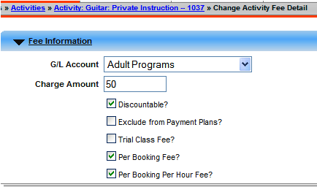

**Change/Add Fees considerations;**

**Volume Pricing:**

***Field:* Volume Plan Name (optional)**

This feature specifically provides the ability to allow volume pricing.

* + Volume pricing is defined in Administration>Registration Settings>Volume Pricing.
  + Volume Pricing provides the ability to assign fees based upon incremental selections.
    - Example: Pricing tier 1 = $100 for 25 Lessons
    - Example: Pricing tier 2 = $150 for 50 Lessons
    - Example: Pricing tier 3 = $300 for 100 Lessons

***Field:* Prices (required)**

Enter the tiers applicable for the Private Lesson.

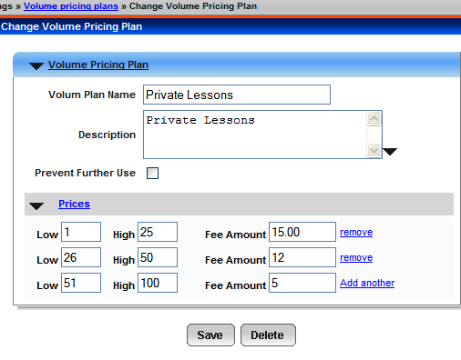

**Below is an example of a Registration Fee:**

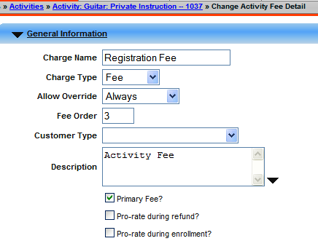

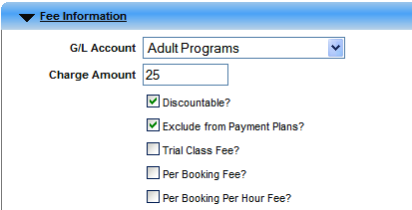

**Change/Add Fees considerations;**

**Multi-Person Registration:**

When creating a multi-person discount, click Add New at the Change Fees screen. Discounts ***cannot*** be embedded in primary fees! All discounts and scholarships must be independent charges within the Private Lesson activity. Therefore, there could easily 6 charges associated with a Private Lesson when considering the Primary Fee, Registration Fee, Scholarship(s), and Discounts.

***Field:* Minimum People (optional)**

Use only if the Charge is designated as a discount for sibling or multi-person discount. The Minimum People value represents the minimum number of registrants enrolled and eligible for the discount. A value of 2 indicates the system will enable the discount when the *second* participant enrolls on the same receipt, or different receipt.

***Field:* Maximum People (optional)**

Use only when enabling the Minimum People field for multi-person discount(s). The Maximum People field defines the maximum number of participants eligible for receiving the multi-person discount.

***Field:* Applies to all registrants up to max? (optional)**

The discount or fee will be applied to each registrant used to reach the ‘Minimum people’ and up to the ‘Maximum people.’ For example; if the ‘Minimum people’ is set to 2 and the ‘Maximum people’ is set to 4, and 5 people were registered, the discount would be applied to persons 1 to 4, but not 5.

If this checkbox is not selected, the fee is only applied to the 'Minimum people' to 'Maximum people' registrants. For example: if the 'Minimum people' was set to 2 and the 'Maximum people' was set to 4, and 5 people were registered, the fee would be applied to people 2 to 4 but not 1 or 5.

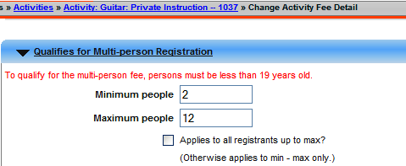

**Change/Add Fees considerations;**

**Multi-Person Registration:**

When creating a multi-person discount, click Add New at the Change Fees screen. Discounts ***cannot*** be embedded in primary fees! All discounts and scholarships must be independent charges within the Private Lesson activity. Therefore, there could easily 6 charges associated with a Private Lesson when considering the Primary Fee, Registration Fee, Scholarship(s), and Discounts.

**Include Prior Registrations:**

***Field:* Within the last (optional)**

Define the last number of months, Semester (season), or Term (sub-season) if the discount is applicable only to a defined previous time period.

Example: If a multi-person discount is applicable for the 2nd registrant enrolling, the values for prior registration will be observed allowing the discount to be eligible even if the qualifying transaction is from a previous receipt. In summary, Registrant 1 can enroll in the fall, and if an immediate family member, Registrant 2 enrolls within the same time parameter, but different receipt, the system will recognize the discount.

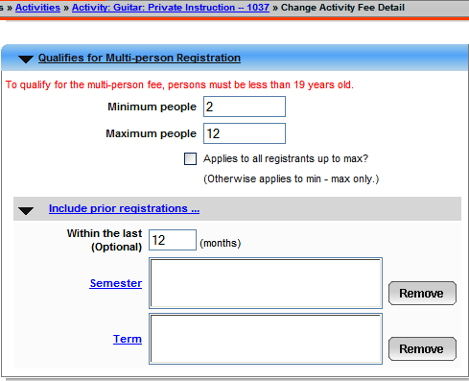

**Back to Activity Functions**

**This screen shows the numerous options available for constructing activities. Not all programs will be used for Private Lessons.**

**The following pages explain how to configure the most commonly used programs associated with Private Lessons.**



**Change Payment Plans**

This option provides the ability to establish pre-defined payment plan(s) specifically for the activity.

Multiple payment plans may be created, however only one default can be assigned

Clicking Add New, populate the following fields:

***Field:* Name (required)**

Enter the name of the payment plan.

Considerations: should the activity offer multiple payment plan options, define according to type of plan.

Example: 90 Day Payment Plan

***Field:* Default Payment Plan? (optional)**

Enable this field if this payment plan will be the default. Checking this field will automatically assume the activity will assign the payment plan during enrollment. The user will be required to *uncheck* this default option should the participant *opt out* of the payment plan.

***Field:* Initial Payment (required)**

Enter the Initial Payment due at the time of enrollment. The value may be dollar or percentage.

***Field:* Automatically Charge credit card? (recommended)**

Enable this field to allow automatic charging to the payer’s credit card when cycle billing occurs.

***Field:* Allow online? (optional)**

Enable this field if customers enrolling online will be permitted to opt in for the payment plan.

***Field:* Use % of Balance per Payment? (optional)**

Enable this field if remaining installments will be segmented according to a percentage value.

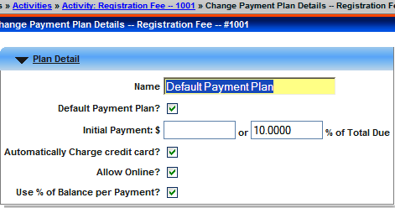

**Payment Schedules**

Payment schedules are required when creating the payment plan. Click Add New to define the payment schedule.

***Field:* Specific Date or # of Days (required)**

List of dates or days included in the payment plan. Clicking this link  opens up a section of the Payment Schedules where you can add of modify dates and days.

***Field:* Percentage of Balance Due (required)**

Percentage of the balance due for the particular payment. Percentage averaged over number of dates or days for the payment plan. If a date/day is added or deleted, the percentage will automatically be re-calculated. Note that this filed will not be displayed if the 'Use % of Balance pre Payment?' checkbox is selected.

***Field:* Plan Description (optional)**An internal description of the payment plan. Text entered will not print on the customers receipt.

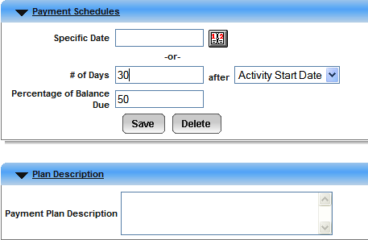

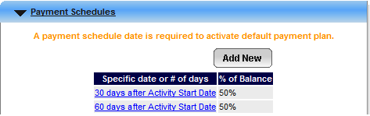

**Payment Plan Usage Charge**

This option provides the ability to apply a service fee for customers opting in for the payment plan. The fee may be excluded from the payment plan should the customer be required to remit payment upon admission.

***Field:* Enable Payment Plan Usage Charge? (optional)**

Check if enabling the service fee charge

***Field:* Charge Name (required)**

Select the applicable charge by using the drop down.

***Field:* Charge Name (required)**

Provides the ability to override the Charge Name description

***Field:* Charge Type (required)**

Provides the ability to override the Charge Type

***Field:* Customer Type (optional)**

Provides the ability to select a Customer Type as a qualifier to the Fee

***Field:* Description (optional)**

Enter an override description of the Charge Name

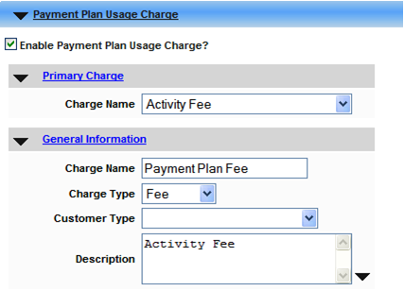

***Field:* GL Account (required)**

Use the default GL account from the Charge or select an alternative using the drop down.

***Field:* Charge Amount (required)**

Enter the amount of the fee

***Field:* Discountable (optional)**

If checked, the fee could be discounted.

***Field:* Exclude from Payment Plans (optional)**

If checked, the fee will be due upon admission.

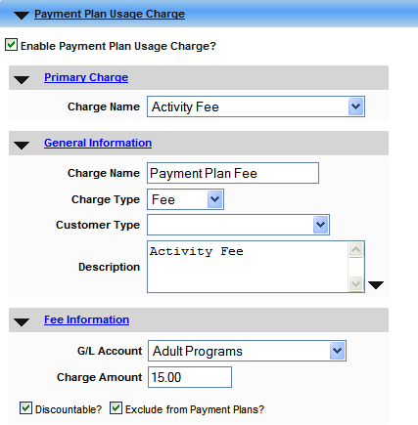

**Custom Questions**

Custom Questions are essential for capturing information related to the participant and course during the enrollment.

Select the applicable custom questions by clicking Add New.

Sequencing and override opportunities are available for customizing when enrolling.

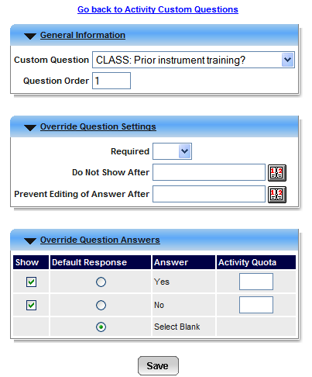

**Interest List**

Interest Lists are used for marketing purposes. Customers enrolling into the activity will be automatically assigned to the Interest List specified for the activity.

Multiple Interest Lists may be assigned to the activity.

Select the applicable Interest List from the Opt-out table and click the >> to assign to the Opt-in table.

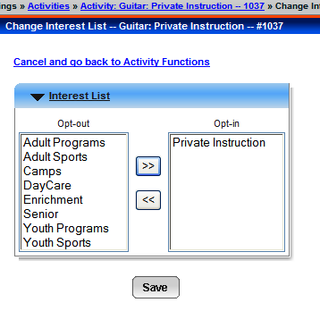

**Checklist Items:**

Checklist Items, or *waivers* can be required or optional during the enrollment. Checklist Items will print on the receipt.

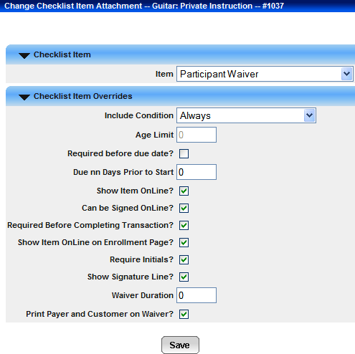

**Sub – Activities**

Use Sub-Activities for ongoing activities, or activities where several enrollment options are available. Examples might be Swim lessons, Martial Arts, Dance, etc.

When building sub-activities, the Parent activity will be a *shell* only. The Parent activity will store everything mentioned in the prior sections ***except the following:***

* Do NOT identify the Maximum capacity. Leave blank and click “Ignore Maximum Participants. You will identify the maximum at the Sub-Activity or “child” activity level.
* Do NOT reserve the facility. Identify the facility(s) and click “Do not Reserve.” You will book the facility when creating the Sub-Activity.

**After creating the Parent Activity Shell, click “Manage Sub-Activities”**

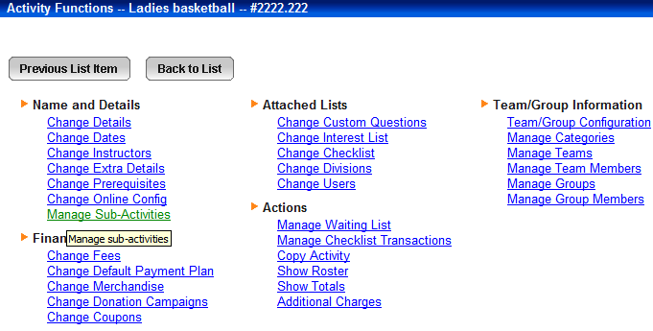

**Click Add New and begin creating the Sub-Activity.**

**All Parent activity information will default to the Sub-Activity.**

**Remember:**

* Title the Activity descriptively:
  + If the Parent Activity is titled “Swim Lessons”, the Sub-Activity might be titled: “Swim Lessons: Session 1 – Ages 8-10
* Reserve Facility
* Identify Maximum number of Participants
* Enter Registration Dates
* Use Skills for activities such as Swim Lessons, Ski Lessons, etc.

**Conclusion**

Based upon the Activity Type, there are several additional programs available for assignment to the activity. Those described in the preceding pages are the most commonly used for Private Lessons.

As the ActiveNet system continues to progress and develop, additional enhancements will be added to the Activities module. Regular review of the new features will assist in determining which features should be enabled.